

Pearle Computer Services, Inc.

Patient Management Information System

Product Information Booklet

“A fully integrated, Windows-based
Practice Management System”

Screen Shots

File Listings and Sample Reports

Pearle Computer Services, Inc.
1135 N.E. 89th Street
Miami, Florida 33138
Tel: (305) 757-8083
Fax: (305) 757-8084
E-mail: sales@pearlecomputer.com
Web page: www.pearlecomputer.com

Patient Management Information System

Practice Solutions using today’s technology

Tools & Solutions

Practice Management


Accounts Receivable

Electronic Claims

Management Reporting

Capitation Evaluation

Managed Care

NEIC Interface

Windows 95 & NT Based

Windows 9x or Windows NT Compatible


Citrix Winframe & Metaframe

Scheduling

Therapy Documentation

Collections Management
Data Conversion
Systems Integration

Patient Management Information System

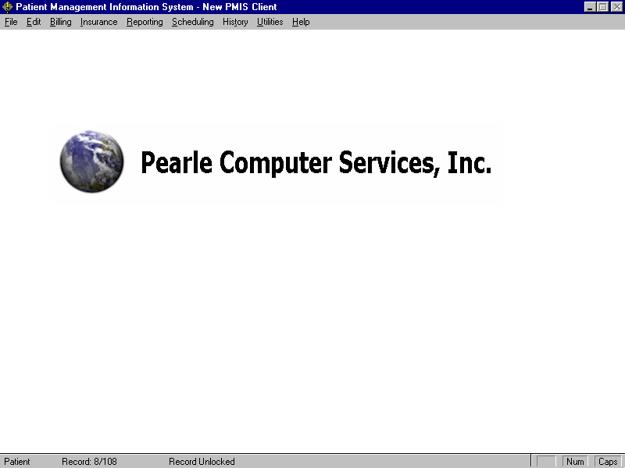
Application Screen Shots

Patient File Maintenance

This screen is used for patient registration and maintenance

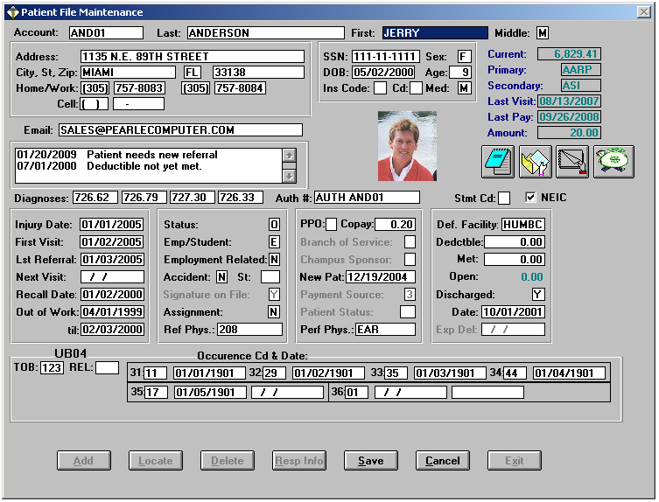
Invoicing

Screen is used to enter charges
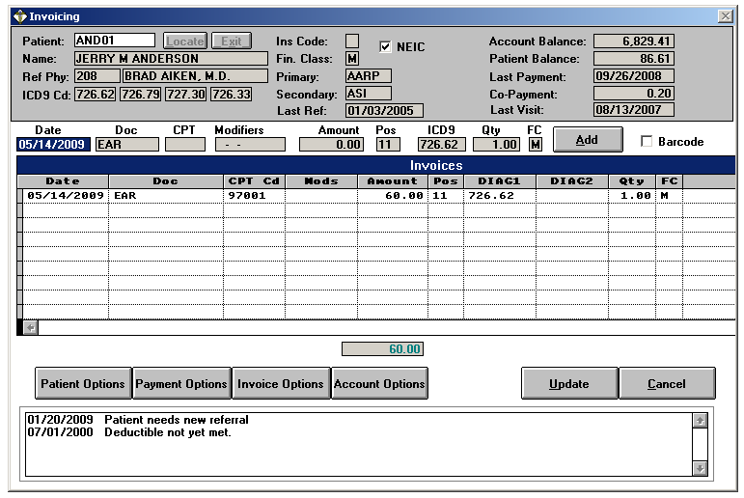

Charge entry interfaces with barcode scanner, and therapy documentation © CIS.

Payments

Screen allows the user to apply Balance Forward
by Date Range or Open Item by line
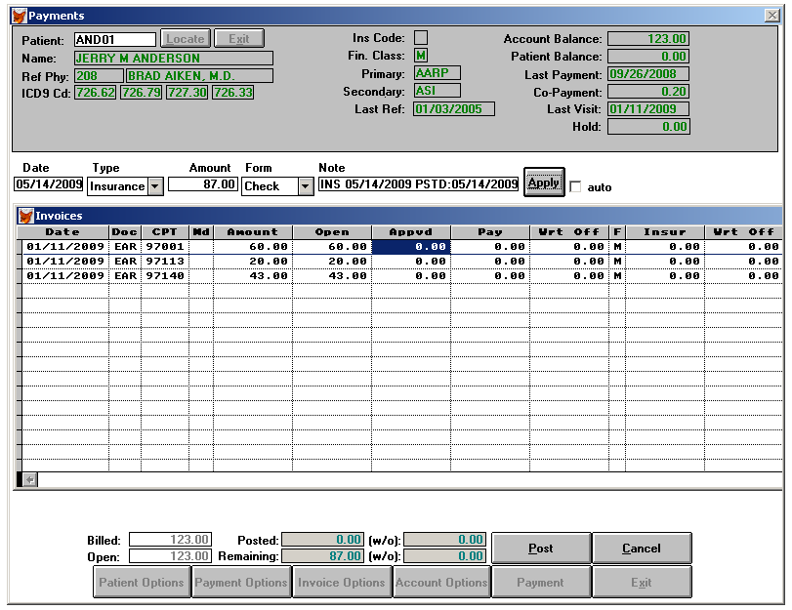

Reporting Menu

Pull down menu offers a Wide Selection of Financial Reports
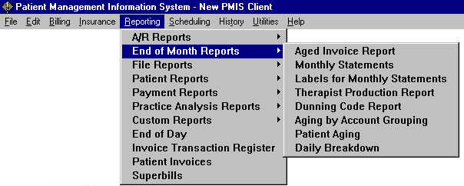

Insurance Billing Options Available

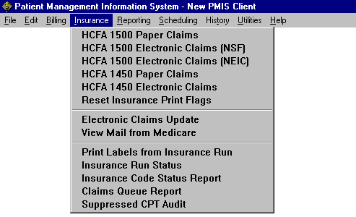
Pull down menu enables the user to print on standard forms or blank paper

Electronic Claims

Menu selections allows the user to extract specific claims to be sent electronically to multiple clearinghouses
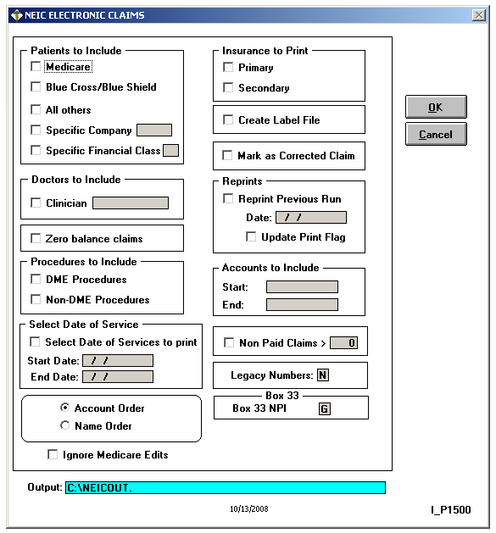

Collections Module

Add-on module enables users to automate the collection process and comprehensively track outstanding accounts
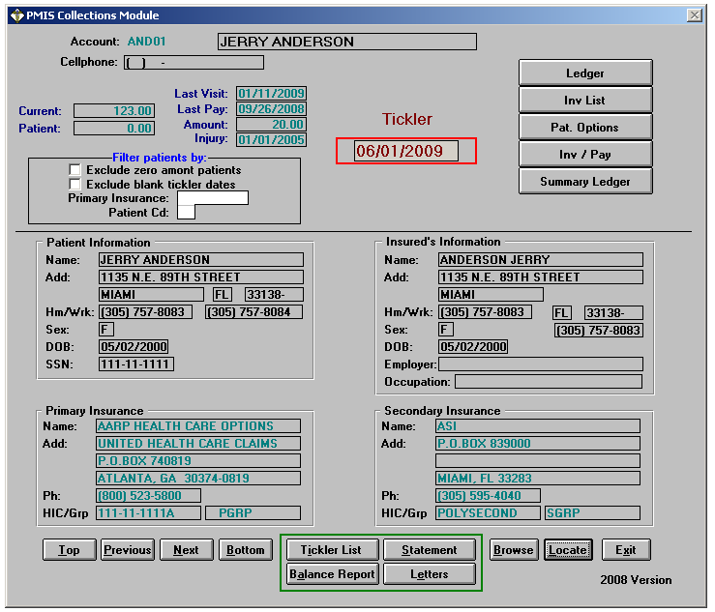

Patient Management Information System

File Listings

Sample Reports
End of Day
End of Month

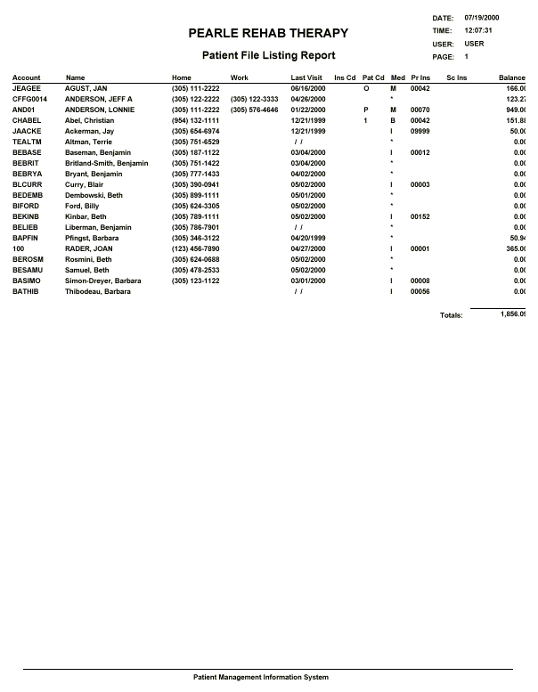

Sample File Listings

End of Day
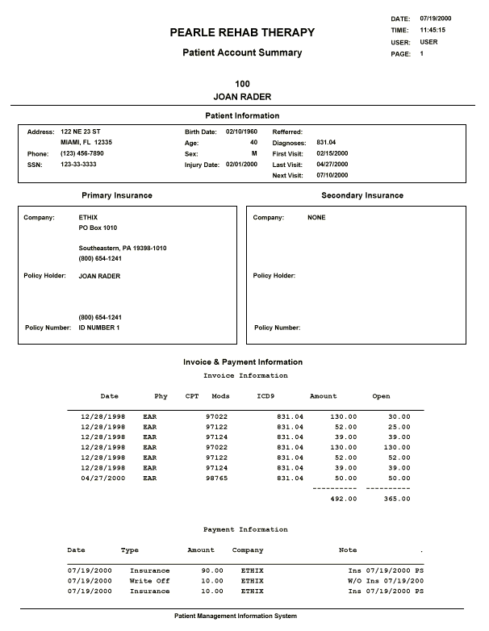

Sample File Listings

End of Day
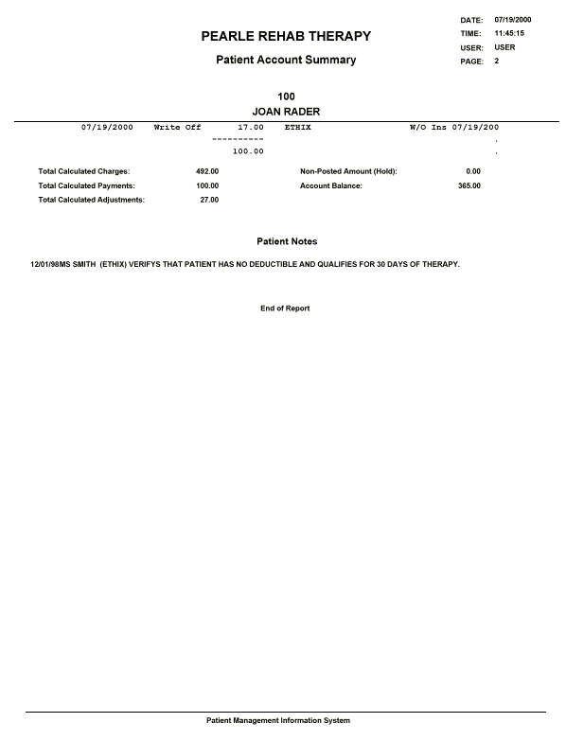

Sample File Listings

End of Day
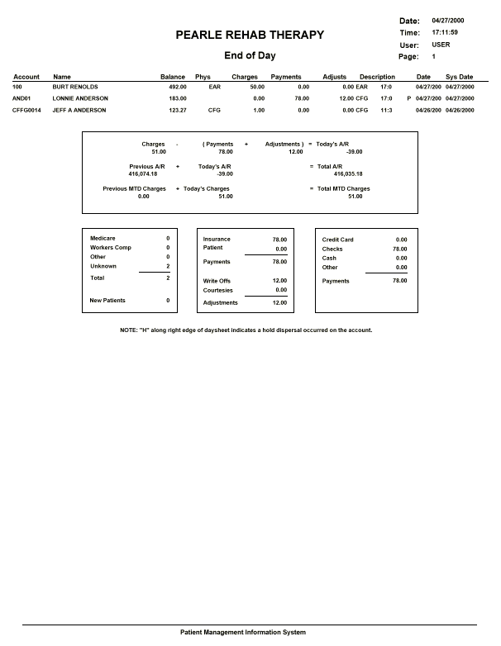

Sample Reports: End of Day

End of Day
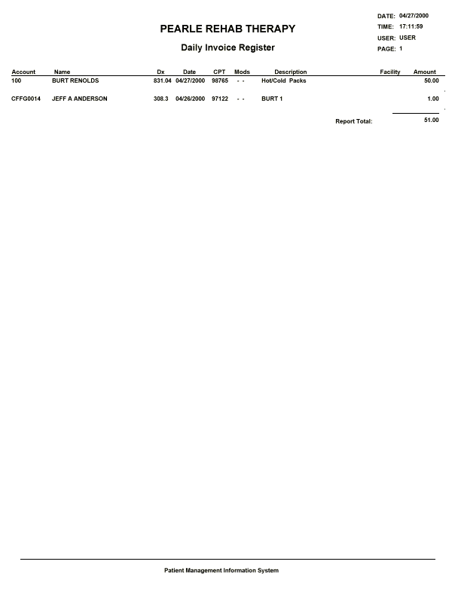

Sample Reports: End of Day

End of Day
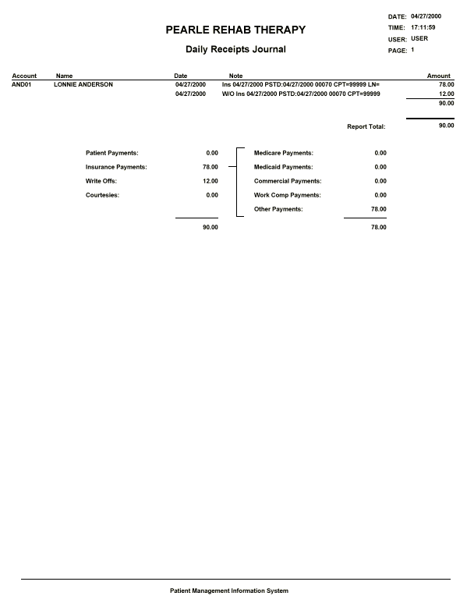

Sample Reports: End of Day

End of Day
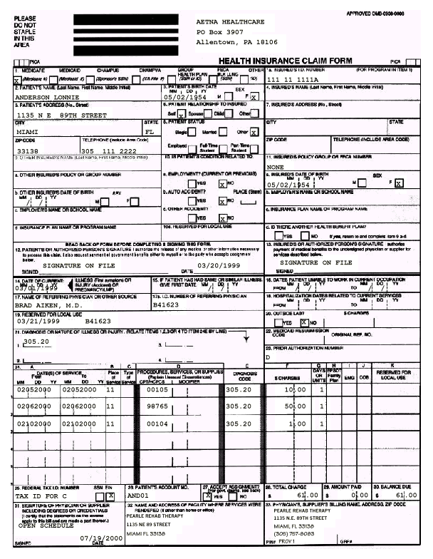

Sample Reports: End of Day

End of Day
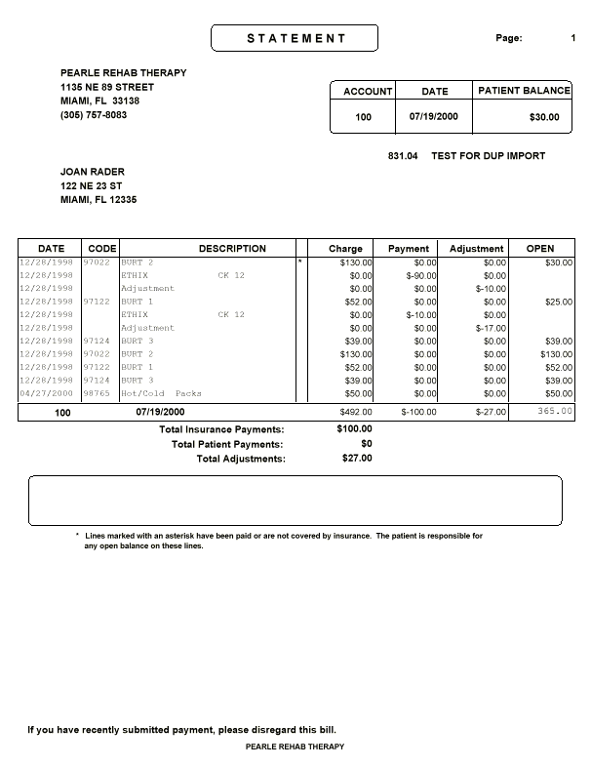

Sample Reports: End of Month

End of Day
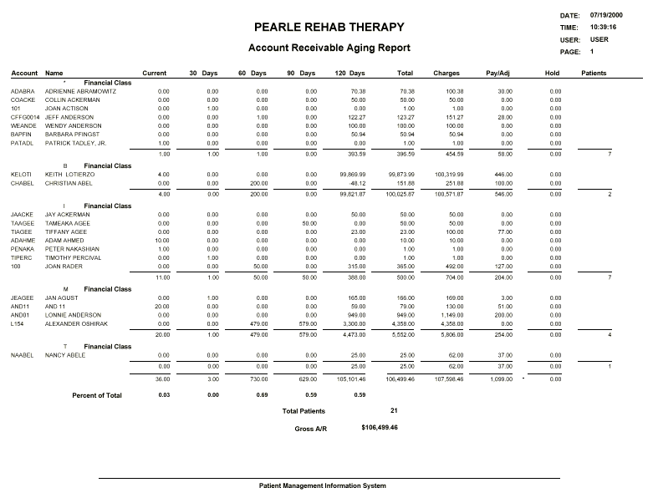

Sample Reports: End of Month

End of Day

